Git-HOL Exercise -3:
Steps:
-Create and switch to a new branch
-Make a change in the new branch
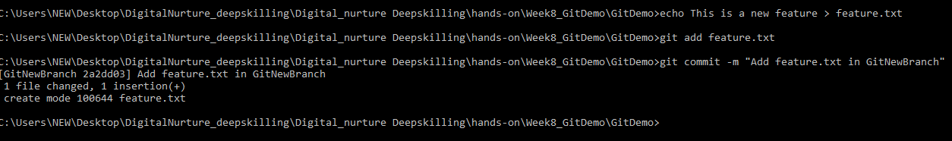
-Check branches
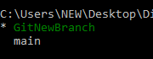
-Compare changes with main branch
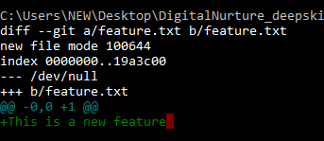
-Switch back to main branch
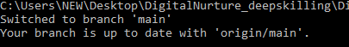

-Merge the new branch into main
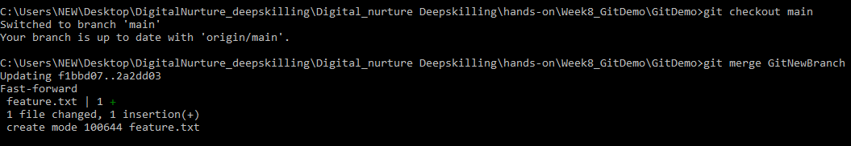
-push the new branch
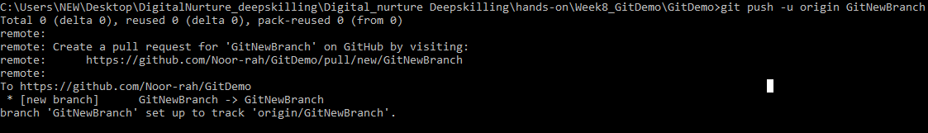
OUTPUT:
